**Assignment -1**

|  |  |
| --- | --- |
| Assignment Date | 27 September 2022 |
| Student Name | Mr.Mari Saravanan P |
| Student Roll Number | 9517201904089 |
| Maximum Marks | 2 Marks |

**Question-1:**

Create registration page in html with username, email and phone number and by using POST method display it in next html page.

**Solution:**

**App.py:**

from flask import Flask,render_template,request

app = Flask(__name__)

@app.route("/")

@app.route("/login")

def login():

return render_template("login.html")

@app.route("/Register",methods=["POST","GET"])

def Register() :

if request.method == "POST" :

name = request.form.get("name")

uname = request.form.get("uname")

email = request.form.get("email")

ph = request.form.get("ph")

return render_template("display.html",name = name ,uname = uname,email = email,phone = ph)

if __name__ == '__main__':

app.run(debug=True)

**login.html:**

<!DOCTYPE html>

<html lang="en">

<head>

<meta charset="UTF-8">

<meta http-equiv="X-UA-Compatible" content="IE=edge">

<meta name="viewport" content="width=device-width, initial-scale=1.0">

<title>HelpLine</title>

<link rel="stylesheet" href="https://cdn.jsdelivr.net/npm/bootstrap@4.0.0/dist/css/bootstrap.min.css"/>

<script src="static/Bootstrap/jquery-3.2.1.slim.min.js"></script>

<script src="static/Bootstrap/popper.min.js"></script>

<script src="static/Bootstrap/bootstrap.min.js"></script>

<style>

.image{

height: 100%;

width : 15rem;

}

.card-body{

border-radius: 2rem;

}

body{

font-family: cursive;

background-color: aquamarine;

}

.btn{

padding-left: 0.5rem;

padding-right: 0.5rem;

font-size: 1.5rem;

background-color:white;

}

.btn:hover{

background-color: black;

color: white;

border-color: black;

}

h4{

text-transform:uppercase;

text-decoration: underline;

margin-left: 5rem;

color:black;

}

</style>

</head>

<body >

<h2 class="mt-2 mb-0 text-center">HelpDesk Welcomes You</h3>

<form action="/Register" class="d-flex align-items-center justify-content-center" method="POST" autocomplete="off">

<div class="card-body mt-5 col-md-5 bg-primary">

<div class="row">

<h4>Registration form</h4>

<br/><br/>

</div>

<div class="row">

<div class="img col-lg-4 ml-0">

<img src="static/images.png" alt="" class="image">

</div>

<div class="register col-md-5 mx-auto">

<div class="form-group">

<label>Name : </label>

<input type="text" class="form-control" name="name" placeholder="name" required>

</div>

<div class="form-group">

<label>Username : </label>

<input type="text" class="form-control" name="uname" placeholder="unique id" required>

</div>

<div class="form-group">

<label>Email : </label>

<input type="text" class="form-control" name="email" placeholder="type valid mail" required>

</div>

<div class="form-group">

<label>Phone : </label>

<input type="text" class="form-control" name="ph" placeholder="10 digit number" required>

</div>

</div>

</div>

<div class="row">

<div class="form-group mt-3 mx-auto">

<input type="submit" class="btn" value = "Register">

</div>

</div>

</div>

</form>

</body>

</html>

**display.html**

<!DOCTYPE html>

<html lang="en">

<head>

<meta charset="UTF-8">

<meta http-equiv="X-UA-Compatible" content="IE=edge">

<meta name="viewport" content="width=device-width, initial-scale=1.0">

<link rel="stylesheet" href="https://cdn.jsdelivr.net/npm/bootstrap@4.0.0/dist/css/bootstrap.min.css"/>

<script src="static/Bootstrap/jquery-3.2.1.slim.min.js"></script>

<script src="static/Bootstrap/popper.min.js"></script>

<script src="static/Bootstrap/bootstrap.min.js"></script>

<title>Help Desk</title>

</head>

<body style="background-color: black;color: aliceblue;">

<div class="row d-flex align-items-center justify-content-center">

<div class="card col-md-5 mt-5" style="background-color:black;">

<h3 class="page-header text-center" style="font-family: cursive;font-size: 2rem;">Dashboard</h3>

<div class="card-body mt-2">

<table class="table table-bordered">

<tr>

<th>Name</th>

<td>{{name}}</td>

</tr>

<tr>

<th>UserName</th>

<td>{{uname}}</td>

</tr>

<tr>

<th>Email</th>

<td>{{email}}</td>

</tr>

<tr>

<th>Phone number</th>

<td>{{phone}}</td>

</tr>

</table>

</div>

</div>

</div>

<div class="row justify-content-center">

<form action="/login">

<input type="submit" class="btn btn-primary" value="back">

</form>

</div>

</body>

</html>

**Output:**

**Register page:**

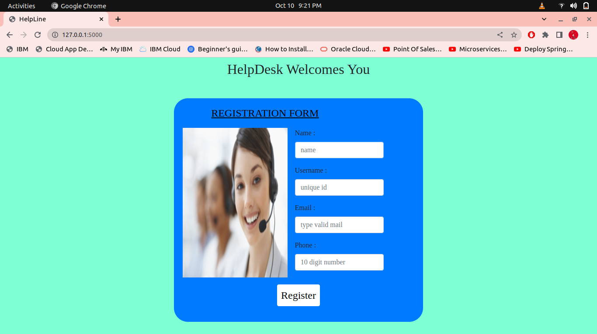

**After Registered successfully:**

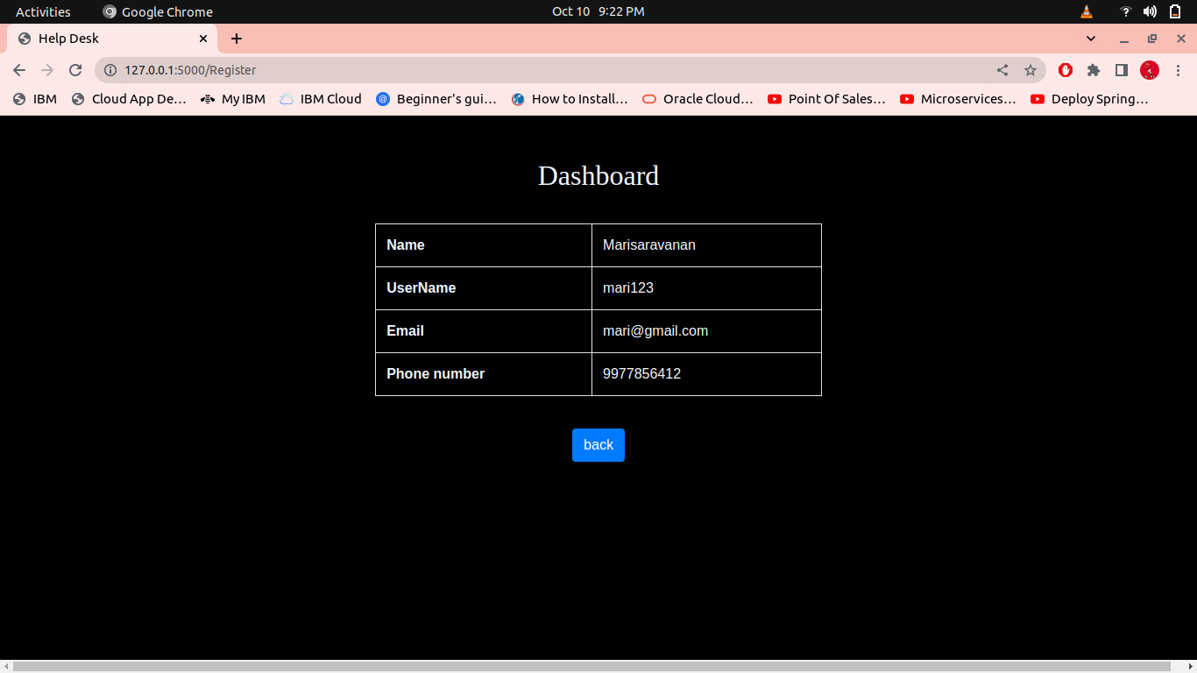

**Question-2:**

Develop a flask program which should contain at least 5 packages used from pypi.org.

**Solution:**

import numpy as np

import pandas as pd

import matplotlib.pyplot as plt

import pendulum

from flask import Flask

import io

from flask import Response

from matplotlib.backends.backend_agg import FigureCanvasAgg as FigureCanvas

from matplotlib.figure import Figure

import seaborn as sns

app = Flask(__name__)

@app.route('/')

def check():

x = 5

y=6

z=np.add(x,y)

return ' %d' %z

@app.route('/plot')

def plot_png():

plt.rcParams["figure.figsize"] = [7.50, 3.50]

plt.rcParams["figure.autolayout"] = True

fig = Figure()

axis = fig.add_subplot(1, 1, 1)

xs = np.random.rand(100)

ys = np.random.rand(100)

axis.plot(xs, ys)

output = io.BytesIO()

FigureCanvas(fig).print_png(output)

return Response(output.getvalue(), mimetype='image/png')

@app.route('/pandas')

def pandas():

ser=pd.Series([0.25,0.7,0.5])

return' %f' %ser[0]

@app.route('/seaborn')

def seaborn():

fig=Figure()

x=[i for i in range(100)]

y=[i for i in range(100)]

sns.set()

fig,ax=plt.subplots(1,1)

sns.lineplot(x,y)

img = io.BytesIO()

FigureCanvas(fig).print_png(img)

return Response(img.getvalue(),mimetype='img/png')

@app.route('/pendulum')

def pendulum1():

local = pendulum.local(2020, 11,27)

zone=local.timezone.name

return '%s' %zone

if __name__ == '__main__':

app.run()

For np:

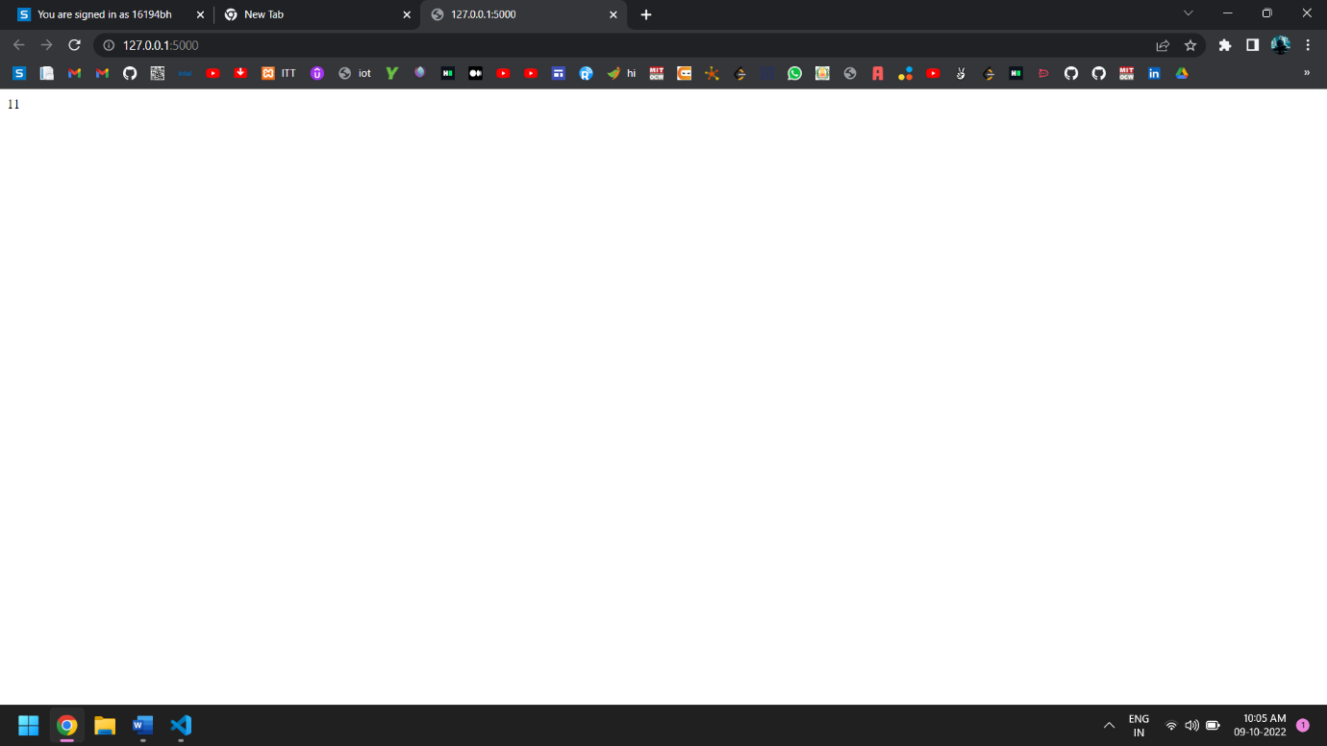

For plot: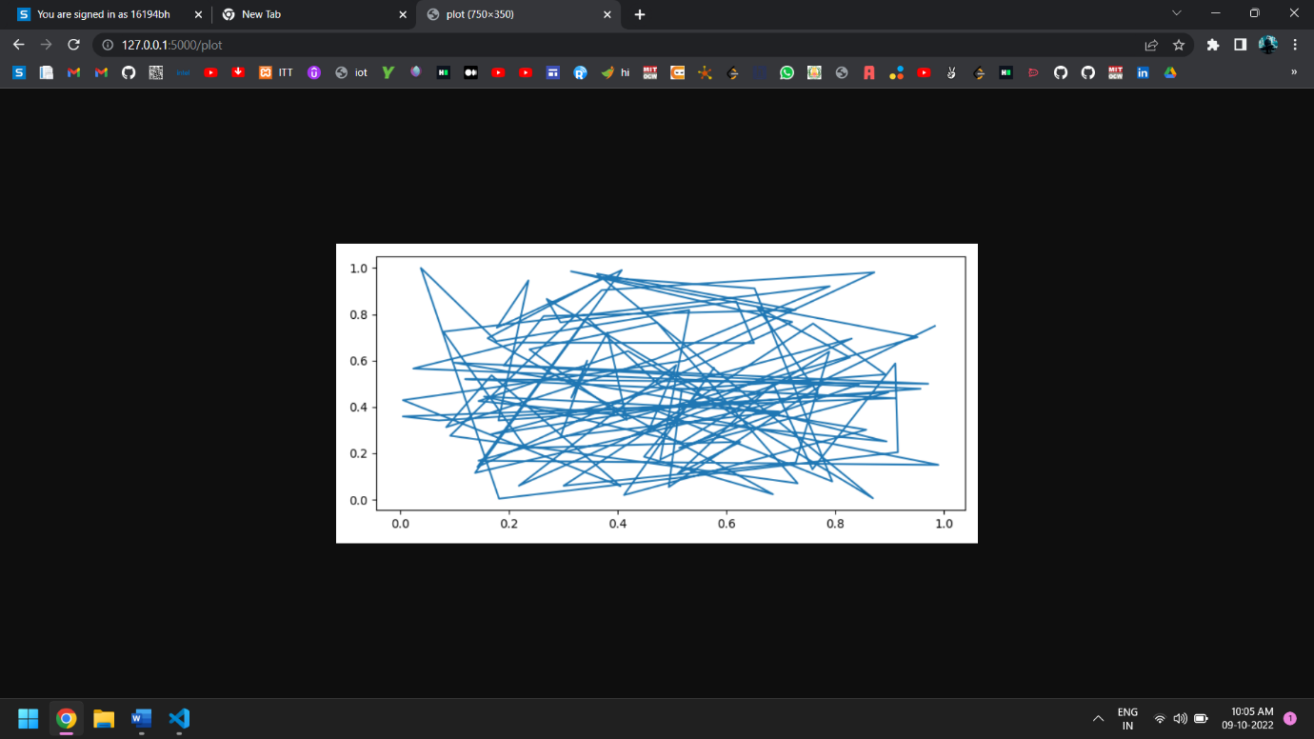

For Pandas: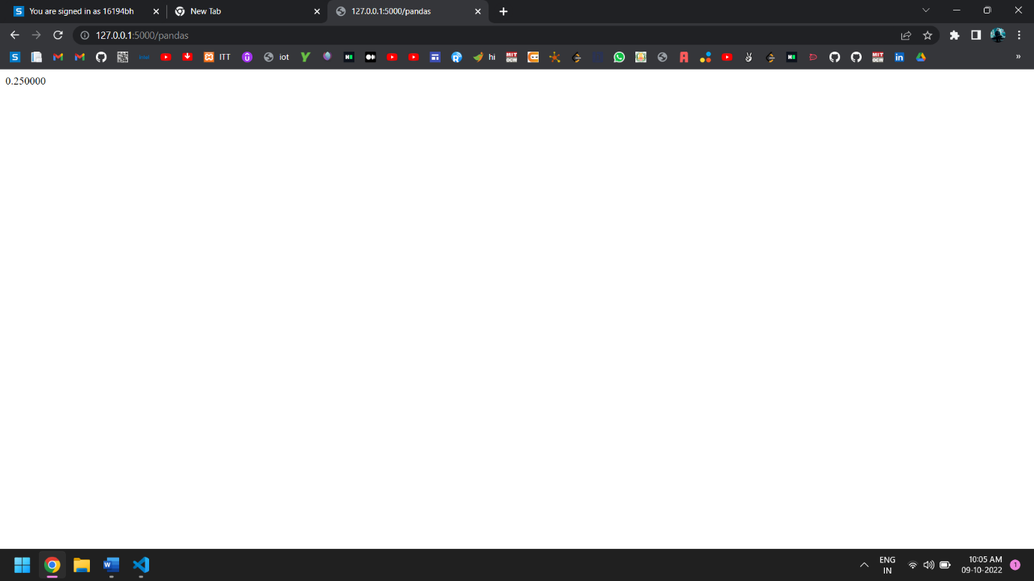

For Pendulum: